CV (Spring 2021)

Name:

**ORB (Oriented FAST and Rotated BRIEF)**

**This project is worth 200 points.**

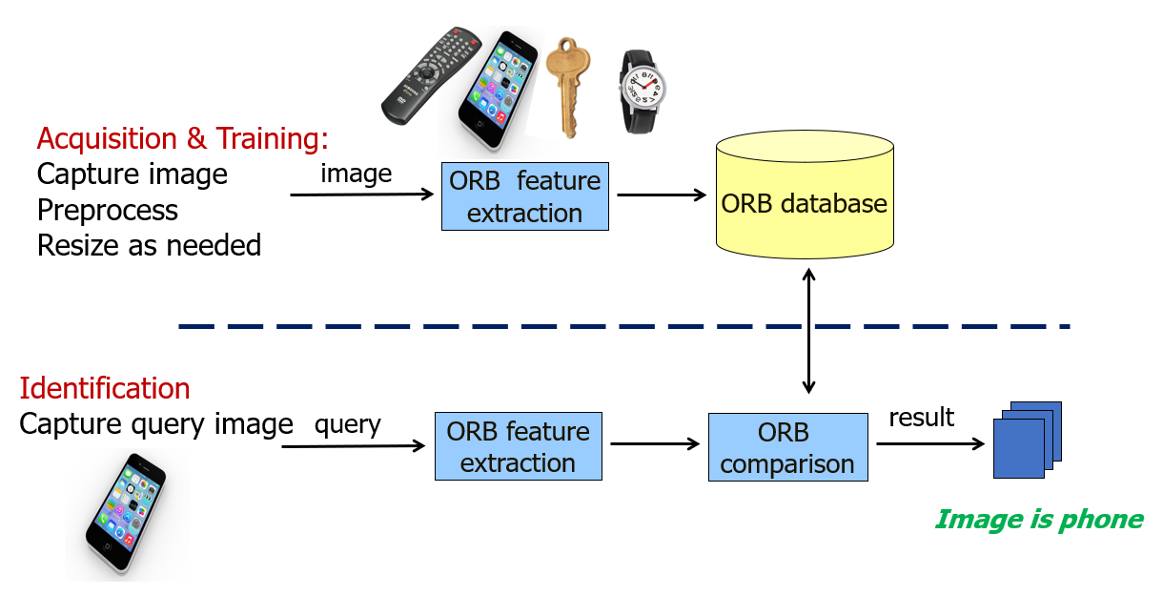

ORB is hailed as a free and efficient alternative to SIFT. In this project, you will use the ORB feature to distinguish among 4 objects: ***a remote control, a phone, a watch, and a key***.

The project will consist of three stages:

* **Acquisition Stage**: In the acquisition stage, you will capture the image of the object to be detected. Capture one image for each object and give it a proper name such as remote_control.jpg, phone.jpg, etc. Store the images in a separate folder.
  + To make things easier for later stages, store all images with a specific size (you can use OpenCV resize functions)
* **Training Stage**: In the training stage, you will extract the feature of each object and store it in a file (remote_control.orb, phone.orb, etc.). Load the files into a data structure so they can be used for classification. features are usually stored in a database, but files are ok for this project.
* **Classification Stage**: in the classification stage, you will identify an object as one of the 4 objects listed above. Start by capturing the image of the object, extract its feature vector and then compare it against the feature vectors of the objects above.

Check the link at <https://docs.opencv.org/master/d1/d89/tutorial_py_orb.html> to learn how to extract the ORB features.

For matching, check the link at <https://docs.opencv.org/master/dc/dc3/tutorial_py_matcher.html> . This a very simple matcher that should do for this project.

1. Use this project to learn the basics of video capture with OpenCV. <https://docs.opencv.org/master/dd/d43/tutorial_py_video_display.html>
2. Although not required for this project, if you plan to go into the OpenCV area, I recommend learning Tkinter, the GUI part of Python.

Along with the code, please write a **word document *report*** that includes:

* **Cover page**: Title, your name, date.
* **Introduction**: overview of feature extraction, ORB, the project with a diagram
* **Results**: table of objects used, orb features, sample queries
* **Discussion**: how did the project go, compare results, any surprises, accuracy, performance etc.
* **Conclusion**: including future enhancements.

**Grading and Submission Guide:**

* Must submit the whole project (python folder with code, image dataset, and results) zipped using 7zip tools with the name: LastName_FirstName_Project-04. Include the report.
* This is an **individual** project: The work should represent your own: that you acknowledge that have not incorporated into this project any unacknowledged material from the work of another person, including papers, words, ideas, information, computer code, data, evidence-organizing principles, or style of presentation taken from the Internet, books, periodicals, or other sources.